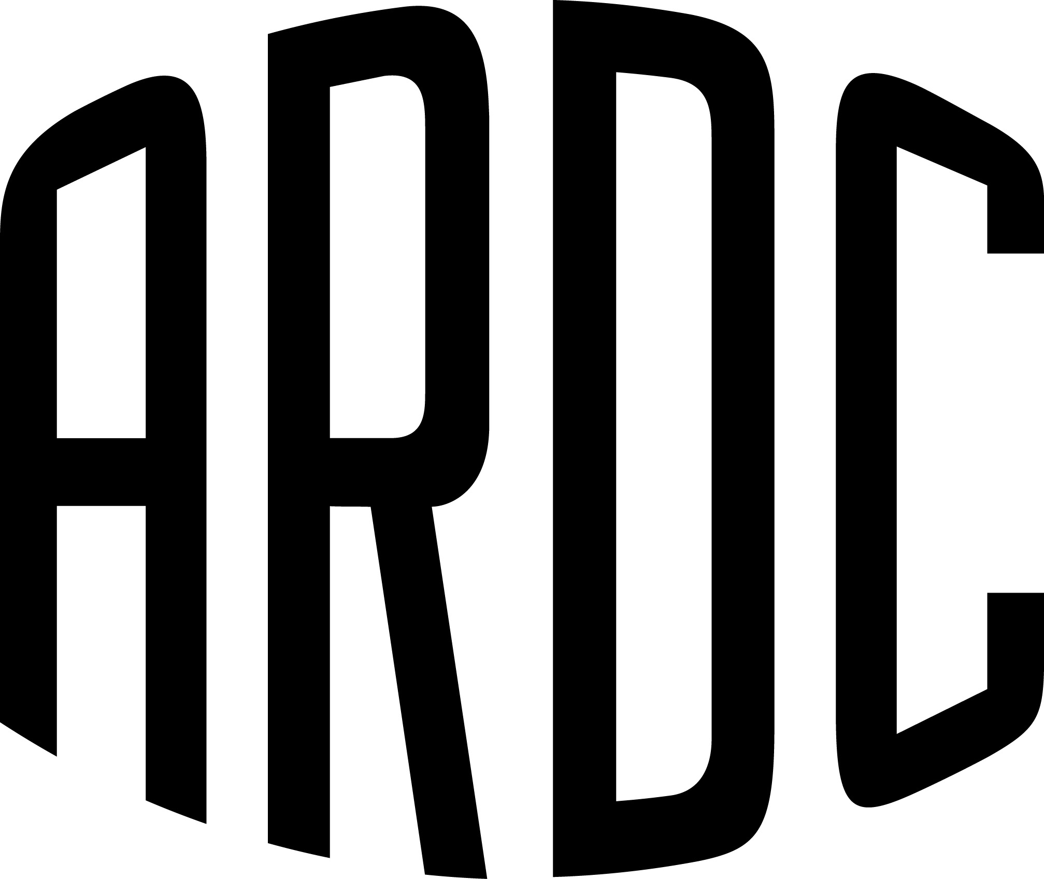
Race # (1st pref)

The Historic Sports & Racing Car Association of NSW Inc
in association with
the Australian Racing Drivers Club Ltd
PRESENTS THE
2016 Sydney Retro racefest at Sydney Motorsport Park
on Saturday 11TH & Sunday 12TH JuNe 2016
ENTRY FORM (Entries close FRIDAY 27th May, 2016)
The meeting will be held under the International Sporting Code of the FIA, the National Competition Rules of the Confederation of Australian Motor Sport Limited (CAMS) and the Supplementary Regulations of the meeting of which this entry form is a part.
CAMS Permit: .................

ENTRY FEES
◻ | $495.00 | RACE OR REGULARITY ENTRY FEE
◻ | $495.00 | CROSS ENTRY INTO ANOTHER CATEGORY (same car, second driver)
◻ | $295.00 | CROSS ENTRY INTO ANOTHER CATEGORY (same or second car, same driver)
Do you require a garage/marquee? |  |  | ◻ | $175.00 (GST included) | Allocated on a first served basis.
Do you require a carport? |  |  | ◻ | $125.00 (GST included) | Allocated on a first served basis.
If your preference is a garage/marquee and is unavailable, would you like a carport? |  |  |  |  | Yes ◻ | No ◻

Please advise with whom you wished to be garaged:

COMPETITOR DETAILS
Competitor: (Owner in Log Book) |  |  |  |  |  |  | CAMS Lic #: |  |  |  |  | Expires:
Team Name: |  |  |  |  |  | CAMS Lic #: |  |  | HSRCA Regularity Licence #:
Driver: |  |  |  |  |  | Car Club: |  |  | Grade: |  |  | Expires:
Emergency contact: |  |  |  |  |  | Emergency Phone:
Address (For all correspondence): |  |  |  |  |  |  |  |  |  |  | Postcode:
Tel (work): |  | Tel (home): |  |  | Mobile:
Email address: |  |  |  |  |  |  | C of D #: |  |  | Alcohol/Fuel?  YES NO
Car Year: | Make: |  |  | Model: |  |  | Colour:
Capacity: |  |  | Log Book #: |  | Class: |  |  | Dorian Transmitter #:

ENTRY FEE PAYMENT DETAILS
I enclose a | Money Order ◻ | Cheque ◻ |  | for the sum of  $
OR pay by Direct Deposit | A/C Name: Historic Sports and Racing Car Asscn of NSW Inc.  BSB: 062-205 Account No: 10007952  Reference: (Surname) – Racefest
OR pay by Credit Card | Visa ◻ | MasterCard ◻
Card Number: |  |  | Card Holders Name:
Expiry Date: |  |  | Signature of card holder:

EXCLUSION OF LIABILITY, RELEASE AND ASSUMPTION OF RISK
COMPETITORS AND/OR DRIVERS

For Competitors
I/We being the competitor/s of the vehicle described on this Entry Form wish to enter that vehicle for the above event.

For Competitors and Drivers
I/We being the competitor/s and/or driver, certify that the particulars on this form are true and correct in every particular, to the best of my/our knowledge and belief.
I/We declare that I/we have read and understood the Supplementary Regulations issued for the event, and agree to be bound by them and the provisions of the National Competition Rules of the Confederation of Australian Motor Sport Limited (“CAMS”).
In exchange for being able to attend or participate in the event (including entering the event), I agree:
- to release CAMS and Australian Motor Sport Commission Ltd, promoters, sponsor organisations, land owners and lessees, organisers of the event, their respective servants, officials, representatives and agents (collectively, the "Associated Entities") from all liability for my death, personal injury (including burns), psychological trauma, loss or damage (including property damage) ("harm") howsoever arising from my participation in or attendance at the event, except to the extent prohibited by law;
- that CAMS and the Associated Entities do not make any warranty, implied or express, that the event services will be provided with due care and skill or that any materials provided in connection with the services will be fit for the purpose for which they are supplied; and
- to attend or participate in the event at my own risk.

I/we acknowledge that the risks associated with attending or participating in the event include the risk that I may suffer harm as a result of:
- motor vehicles (or parts of them) colliding with other motor vehicles, persons or property;
- acts of violence and other harmful acts (whether intentional or inadvertent) committed by persons attending or participating in the event; and
- the failure or unsuitability of facilities (including grand-stands, fences and guard rails) to ensure the safety of persons or property at the event.

I/we acknowledge that motor sport is dangerous and that accidents causing harm can and do happen and may happen to me.

I accept the conditions of, and acknowledge the risks arising from, attending or participating in the event and being provided with the event services by CAMS and the Associated Entities.

I understand that this disclaimer is not intended to exclude any valid claim I may have under the CAMS Personal Insurance Scheme.
Competitor's signature: .................................................................................................. Date: ........................................
Driver’s signature: .................................................................................... Date: ........................................
Second Driver’s Signature ................................................................................................... Date: ........................................

For persons under the age of 18 years the following parent/guardian consent must be completed.

PARENT/ GUARDIAN CONSENT – PERSONS UNDER 18 YEARS OLD

I …………………………………… of [Address] ………………………………………………… am the parent/ guardian* of the above-named ("the minor") who is under 18 years old. I have read this document and understand its contents, including the exclusion of liability and assumption of risk, and have explained the contents to the minor. I consent to the minor attending/ participating in* the event at his/her own risk.
Signed ………………………………………………… Parent/Guardian* * Delete whichever does not apply | Date…………………………………………………

Unless entry has been made via CAMSEventEntry (www.meecamsau.com)
all paper entry forms and fee payments are to be returned to:
Australian Racing Drivers Club,
PO Box 6747, Blacktown DC, NSW, 2148 or
Email: alex@ardc.com.au

