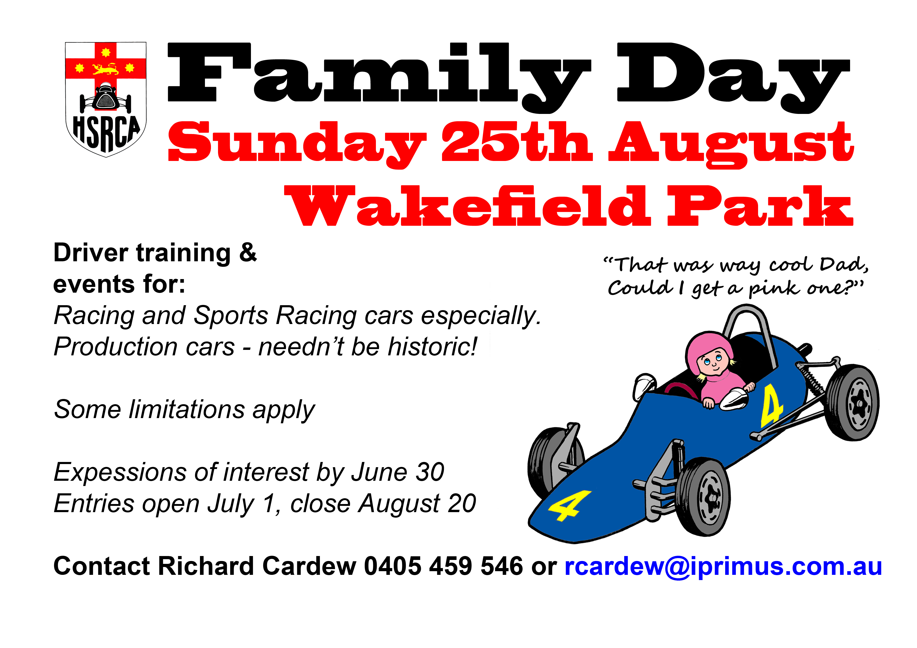

Return this portion

EXPRESSION OF INTEREST

Family Day Wakefield Park Sunday 25 August 2013

Name
Expressing interest on behalf of: | Date of Birth:  Land line  Mobile
Self | Date of Birth:  Land line  Mobile
Family member of friend | Date of Birth:  Land line  Mobile
Club member, friend or family of: HSRCA, Other please circle

Vehicle:
Make: |  | Model: | Year:
Capacity: | Modifications: standard, minor, major, please circle

Post to: HSRCA, PO Box 5063, Turramurra South 2074
Email to: members@hsrca.org.au or Fax to: 02-9988 4277

