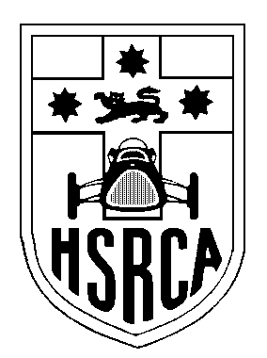
Historic Sports & Racing Car Association
of New South Wales, Inc.
PO Box 1774, Warriewood, NSW, 2102
Phone: 02 9999 6579, email: members@hsrca.com
ABN 58 251 017 401

Membership Application

I wish to be nominated for election as a member of the Historic Sports and Racing Car Association.
If elected, I will abide by the Constitution of the Club.

Surname: ____________________________ Given Names: _________________________________________
Title: ____ Preferred First Name: _____________________ Full or Associate Membership: __________
(An Associate Member is a spouse/partner/family member of a full Financial Member)
Address: _______________________________________________________________________________
Suburb: ____________________________________________________State: _____ Postcode: _______
Profession: ______________________________________ Date of Birth ____/____/____ (confidential)
Home Telephone: ________________________ Work Telephone: ________________________
Mobile: ___________________________ E-mail address: _____________________________________

Please tick this box if you do not want your contact details passed on to other members.

I own the following Historic cars: (and I am prepared to have this information published
in the New Members’ section of “The Oily Rag”). Use back of form if more space needed.

Year Make Model Group Log Book

Payment may be made by cheque made payable to the HSRCA, direct deposit or credit card (MasterCard or Visa only):

New Member Fee (with Club cloth badge a sticker/transfer) incl. GST $10.00
Plus
Full Member to 30th June 2025, incl. GST ⁽¹⁾ $135.00 ⁽²⁾
or
Associate Membership (see above) to 30th June 2025 incl. GST $60. 00 ⁽²⁾
(please provide name of related full member)
TOTAL $____________

Signed: ______________________________________________ Date: __________________

Direct Deposit to HSRCA: BSB 062 205; Acct # 1000 7952.

Payment by credit card (Mastercard or Visa only).

Expiry ………./……...
………………………………………………….. ……………………………………………………..

Name on Card Signature of card holder

- The HSRCA prefers to communicate with its members via email and our website. But if you do not have the capacity to receive electronic messages, please contact the club to arrange to have your newsletters delivered by mail.
- The HSRCA membership year runs from 01 July to 30 June. For applications made for less than a full year, please contact the club for the discounted amount.

