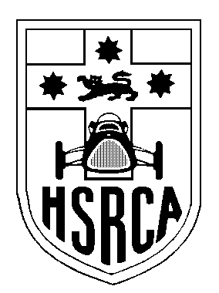 Membership Renewal 2025-2026
Historic Sports & Racing Car Association
of New South Wales, Inc.
PO Box 1774, Warriewood, NSW 2102
Phone 02-9999 6579, email: members@hsrca.com
Tax Invoice: ABN 58 251 017 401

Member No.

Correction
Name for mailing:
Address:
Profession:
Date of birth:
Home Phone:
Work Phone:
Mobile Phone:
E-mail:

Please tick this box if you do not want your contact details passed on to other members.

Full Member Annual Subscription to 30th June 2026, incl. GST $140.00
or
Associate Member Annual Subscription to 30th June 2026, incl. GST $65.00 (An Associate member is a spouse/partner/son/daughter of a Full Member)

Payment Options: cheque, credit card or direct bank transfer. TOTAL $__________

Note: It has been decided to no longer charge extra for delivery of our newsletter by post. However, we encourage anyone who can receive them electronically to do so. We will assume that everyone having an email address will use it, but if it is not possible to receive newsletters electronically, please let us know.

Direct bank transfer details: Commonwealth Bank, BSB: 062 205; Acct No: 1000 7952
If using this payment option please include the following reference: M

Payment by cheque or credit card (Mastercard or Visacard only).

Expiry ______/_______
………………………………………………….. …………………………………………………..

Name on Card Signature of card holder

If you pay by bank transfer and there are no changes to the information above, it is not necessary to return this form; just be sure to include your membership number when you make your transfer.

